**ASSIGNMENT – 4**

**COURIER MANAGEMENT SYSTEM**

Task 1: Control Flow Statements

**CODE:**

# Check Order Delivery Status

status = "Delivered"

if status == "Delivered":

print("The order has been delivered.")

elif status == "Processing":

print("The order is still being processed.")

elif status == "Cancelled":

print("The order has been cancelled.")

else:

print("Invalid order status.")

**OUTPUT:**



**CODE:**

# Categorize Parcels Based on Weight

def categorize_parcel(weight):

weight_categories = {

0: "Light",

1: "Light",

2: "Light",

3: "Light",

4: "Medium",

5: "Medium",

6: "Medium",

7: "Heavy",

8: "Heavy",

9: "Heavy"

}

category = weight_categories.get(weight, "Heavy")

return category

parcel_weight = int(input("Enter Weight:"))

result = categorize_parcel(parcel_weight)

print(f"The parcel is categorized as {result}.")

**OUTPUT:**



**CODE:**

# User Authentication

def authenticate_user(username, password):

valid_username = "user123"

valid_password = "pass456"

if username == valid_username and password == valid_password:

return True

else:

return False

entered_username = input("Enter username: ")

entered_password = input("Enter password: ")

if authenticate_user(entered_username, entered_password):

print("Login successful!")

else:

print("Invalid username or password. Please try again.")

**OUTPUT:**

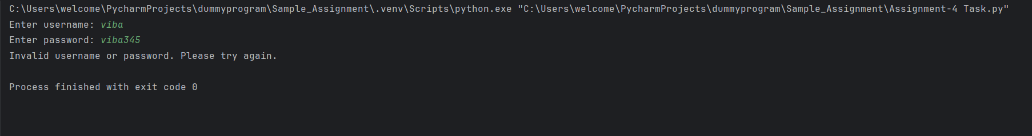

**CODE:**

# Courier assignment Logic

def assign_courier(proximity, load_capacity):

while proximity > 0 and load_capacity > 0:

if 0 < proximity < 10 and load_capacity > 5:

print("Assigning courier...")

else:

print("No available courier meeting the criteria.")

proximity = float(input("Enter shipment proximity (in km): "))

load_capacity = float(input("Enter courier load capacity (in kg): "))

shipment_proximity = float(input("Enter shipment proximity (in km): "))

courier_load_capacity = float(input("Enter courier load capacity (in kg): "))

assign_courier(shipment_proximity, courier_load_capacity)

print("Exiting courier assignment program.")

**OUTPUT:**



**TASK:2**

**CODE:**

#Display All Orders for a Specific Customer

def display_customer_orders(customer_id, orders):

for order in orders:

if order["customer_id"] == customer_id:

print(f"Order ID: {order['order_id']}, Status: {order['status']}")

customer_id = 123

sample_orders = [

{"order_id": 1, "customer_id": 123, "status": "Delivered"},

{"order_id": 2, "customer_id": 456, "status": "Processing"},

{"order_id": 3, "customer_id": 123, "status": "Cancelled"},

]

display_customer_orders(customer_id, sample_orders)

**OUTPUT:**



**CODE:**

# Track Real-Time Location of a Courier

def track_courier_location(destination, current_location):

while current_location != destination:

print(f"Courier is currently at {current_location}.")

current_location += 1

print("Courier has reached the destination.")

courier_destination = 10

courier_current_location = 0

track_courier_location(courier_destination, courier_current_location)

**OUTPUT:**

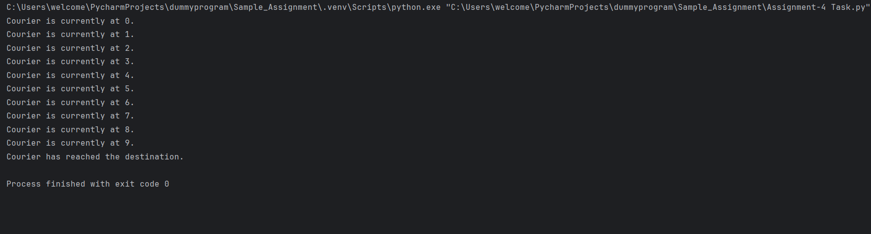

**TASK 3**

**CODE:**

# Store Parcel Tracking History

def store_parcel_tracking(parcel_id, location, tracking_history):

entry = {"parcel_id": parcel_id, "location": location}

tracking_history.append(entry)

parcel_tracking_history = []

store_parcel_tracking(1, "Warehouse A", parcel_tracking_history)

store_parcel_tracking(1, "Distribution Center", parcel_tracking_history)

store_parcel_tracking(1, "Customer Address", parcel_tracking_history)

print("Parcel Tracking History:")

for entry in parcel_tracking_history:

print(f"Parcel ID: {entry['parcel_id']}, Location: {entry['location']}")

**OUTPUT:**

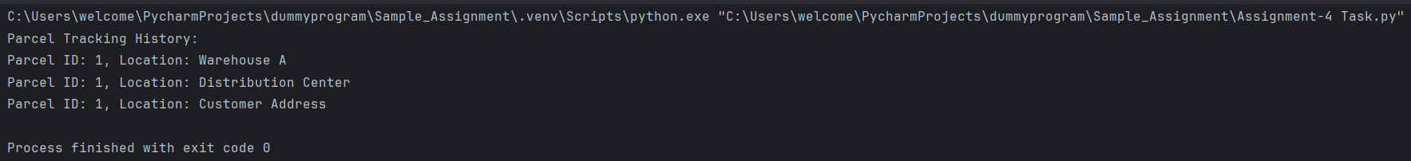

**CODE**

def find_nearest_courier(customer_location, courier_locations):

nearest_courier = None

min_distance = float('inf')

for courier_location in courier_locations:

distance = abs(customer_location - courier_location)

if distance < min_distance:

min_distance = distance

nearest_courier = courier_location

return nearest_courier

customer_address = 5

courier_locations = [8, 3, 1, 4]

nearest_courier = find_nearest_courier(customer_address, courier_locations)

if nearest_courier is not None:

print(f"The nearest available courier is at location {nearest_courier}.")

else:

print("No available couriers.")

**OUTPUT**

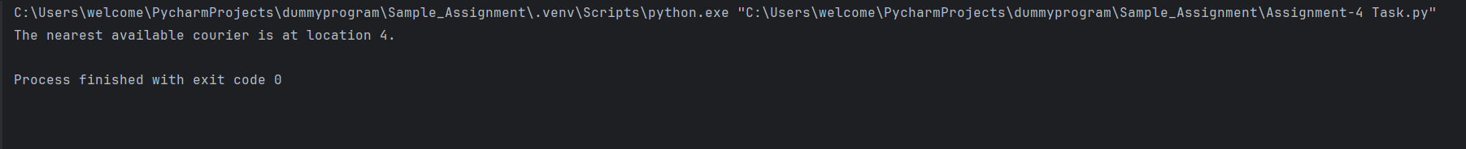

**COURIER INFORMATION SYSTEM**

**CODE:**

# create database connection

import mysql.connector as con

connect = con.connect(host="localhost", user="root", password="root", database="cis")

# Get user details

def user():

id = input("Enter User Id: ")

data = (id,)

sql = " select * from user where userid = %s; "

c = connect.cursor()

c.execute(sql, data)

list = c.fetchall()

for i in list:

print("Name: ", i[1])

print("Email: ", i[2])

print("Password: ", i[3])

print("Contact: ", i[4])

print("Address: ", i[5])

print("-----------------------------------")

menu()

# updating courier status

def update_courier_status():

Id = input("Enter Courier Id:")

Status = input("Courier status:")

data = (Status, Id)

q1 = "update courier set Status = %s where courier_id = %s;"

c = connect.cursor()

c.execute(q1, data)

connect.commit()

print("....Updation done successfully....")

menu()

# revenue report

def revenue_report():

payment_id = input("Enter Payment Id: ")

data = (payment_id,)

sql = " select * from payment where Payment_ID = %s; "

c = connect.cursor()

c.execute(sql, data)

list = c.fetchall()

for i in list:

print("Courier Id is: ", i[1])

print("Location Id: ", i[2])

print("Amount: ", i[3])

print("Payment Date: ", i[4])

print("Payment Date: ", i[5])

print("Employee Id:", i[6])

print("-----------------------------------")

menu()

# shippment status report

def shippment_status_report():

package_id = input("Enter Package Id: ")

data = (package_id,)

sql = " select * from packages where Package_ID = %s; "

c = connect.cursor()

c.execute(sql, data)

list = c.fetchall()

for i in list:

print("Order Id is: ", i[1])

print("Package_Details: ", i[2])

print("Shipping_Status: ", i[3])

print("Courier Id :", i[4])

print("-----------------------------------")

menu()

# courier services

def courier_services():

id = input("Enter Service Id: ")

data = (id,)

sql = " select * from courier_services where service_id = %s; "

c = connect.cursor()

c.execute(sql, data)

list = c.fetchall()

for i in list:

print("Service Name : ", i[1])

print("Cost: ", i[2])

print("-----------------------------------")

menu()

def menu():

print("Select an option:")

print("1.Shipment Status Report")

print("2.Update Courier Status")

print("3.Revenue Report")

print("4.Get Courier Services")

print("5.Get User Information")

print("6.Exit")

option = input("Enter option: ")

if option == '1':

shippment_status_report()

elif option == '2':

update_courier_status()

elif option == '3':

revenue_report()

elif option == '4':

courier_services()

elif option == '5':

user()

elif option == '6':

print("....Exit....")

else:

print("Invalid option...\n Try again...")

menu()

menu()

OUTPUT:

